Chapter 3, Solution 66

The mesh equations are obtained as follows.

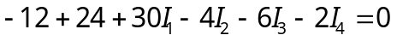
or
30I₁ – 4I₂ – 6I₃ – 2I₄ = –12 (1)
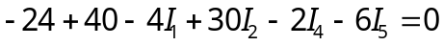
or
–4I₁ + 30I₂ – 2I₄ – 6I₅ = –16 (2)

–6I₁ + 18I₃ – 4I₄ = 30 (3)

–2I₁ – 2I₂ – 4I₃ + 12I₄ –4I₅ = 0 (4)

–6I₂ – 4I₄ + 18I₅ = –32 (5)

Putting (1) to (5) in matrix form

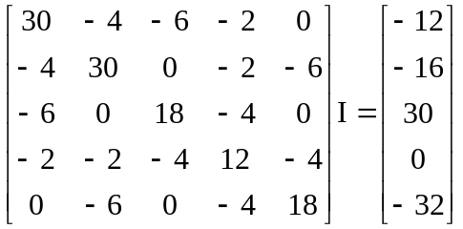

ZI = V

Using MATLAB,

>> Z = [30,-4,-6,-2,0;
-4,30,0,-2,-6;
-6,0,18,-4,0;
-2,-2,-4,12,-4;
0,-6,0,-4,18]

Z =

30 -4 -6 -2 0
-4 30 0 -2 -6
-6 0 18 -4 0
-2 -2 -4 12 -4
0 -6 0 -4 18

>> V = [-12,-16,30,0,-32]'

V =

-12
-16
30
0
-32

>> I = inv(Z)*V

I =

-0.2779 A
-1.0488 A
1.4682 A
-0.4761 A
-2.2332 A

